output for assistant with confidence module

🔄 Re-initializing assistant with Confidence Module...
Loading weights: 100%
103/103 [00:00<00:00, 2744.02it/s]
Initializing Gemini 2.5 Flash...
Loading Cross-Encoder reranker...
Loading weights: 100%
105/105 [00:00<00:00, 3994.00it/s]
Successfully loaded 16407 medical documents.

🔍 Querying: What are the main risk factors and symptoms of heart disease?

--- Assistant's Answer ---
The main risk factors for heart disease include both factors you can control and those you cannot. The primary symptom mentioned is chest pain.

* **Risk Factors You Can Control:**
* **Smoking:** Significantly increases the risk of heart disease [Source 1, Source 2, Source 3, Source 4, Source 5].
* **High Blood Pressure (Hypertension):** Strains the heart and damages blood vessels [Source 1, Source 2, Source 3, Source 4, Source 5].
* **High Blood Cholesterol and Abnormal Blood Fat Levels:** High LDL (bad) cholesterol and triglycerides, and low HDL (good) cholesterol, can lead to plaque buildup in arteries [Source 1, Source 2, Source 3, Source 4, Source 5].
* **Overweight and Obesity:** Especially central obesity (extra weight around the waist), increases the risk [Source 1, Source 2, Source 3, Source 4, Source 5].
* **Unhealthy Diet:** Diets high in saturated fat, trans fat, cholesterol, and sodium contribute to risk [Source 1, Source 4].
* **Lack of Routine Physical Activity:** Increases the risk of heart disease [Source 1, Source 2, Source 4, Source 5].
* **High Blood Sugar (Insulin Resistance or Diabetes/Prediabetes):** Diabetes itself is a major risk factor for heart disease and stroke [Source 1, Source 2, Source 3, Source 4, Source 5].
* **Metabolic Syndrome:** A cluster of conditions including obesity, high blood pressure, and high blood sugar, which doubles the risk of heart disease [Source 1].
* **Stress:** Can be a risk factor for coronary heart disease [Source 4].
* **Intravenous Drug Use:** Increases the risk of infective endocarditis, which is a risk factor for heart valve disease [Source 2].

* **Risk Factors You Cannot Control:**
* **Age:** The risk increases for men after age 45 and for women after age 55 (or after menopause) [Source 1, Source 4, Source 5]. Older age is also a risk factor for heart valve disease [Source 2].
* **Family History of Early Heart Disease:** Increased risk if a father or brother was diagnosed before age 55, or a mother or sister before age 65 [Source 1, Source 2, Source 3, Source 4, Source 5].
* **Preeclampsia:** A condition during pregnancy linked to an increased lifetime risk of heart disease [Source 1].
* **Gender:** Is a non-controllable risk factor for CHD [Source 4].
* **History of Certain Conditions:** Previous infective endocarditis, rheumatic fever, heart attack, heart failure, or heart valve disease [Source 2, Source 5].
* **Congenital Heart Conditions:** Such as a bicuspid or bicommissural aortic valve, which increases the likelihood of aortic heart valve disease [Source 2].
* **Previous Heart Procedure:** Such as angioplasty or heart bypass [Source 5].

* **Symptoms of Heart Disease:**
* **Chest Pain:** Reduced blood flow to the heart muscle due to plaque buildup can cause chest pain, especially when active [Source 4]. Angina, which is chest pain, is also mentioned as a personal history that increases risk [Source 5].

--- Confidence Metrics ---
Overall Confidence Score: 84.56%
Retrieval Quality: 98.89%

Screenshot
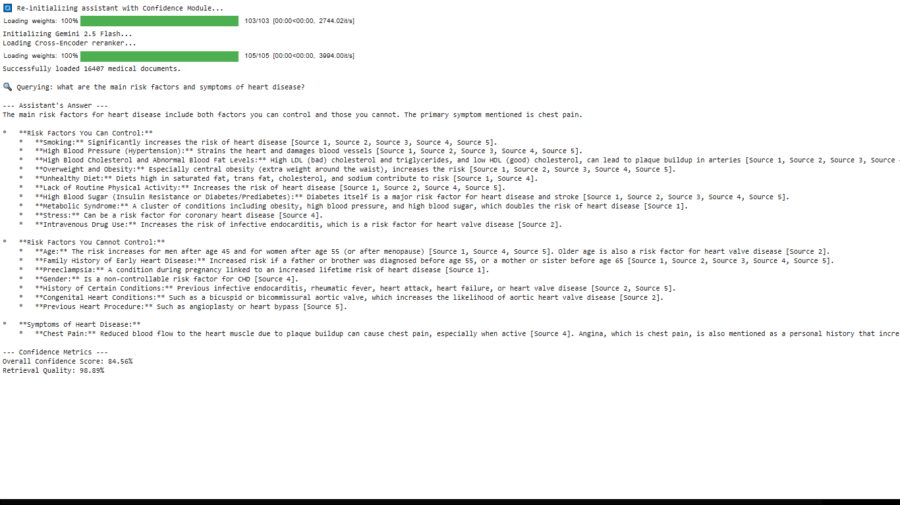
OVERALL INTERACTIVE MEDQUAD ASSISTANT OUTPUT :

--- Medical Assistant Ready (Type 'exit' to quit) ---

Patient Query: what are the symptoms,treatment and prevention of malaria
🔍 Analyzing sources and generating answer...

==================================================
⚕️ ASSISTANT RESPONSE
==================================================
* Malaria symptoms can range from absent or very mild to severe disease and death [Source 1].
* Common symptoms include high fevers, shaking chills, and flu-like illness [Source 1].
* Other symptoms may include chills, fever, vomiting, diarrhea, and jaundice [Source 2].
* Malaria is a curable disease if diagnosed and treated promptly and correctly [Source 1].
* Treatment involves drugs, and the specific type depends on factors such as disease severity, the species of malaria parasite, and where the infection was acquired [Source 1, Source 2].
* Malaria can be prevented, especially when traveling to areas where it is found [Source 2].
* Prevention methods include seeing a doctor for protective medicines, wearing insect repellent with DEET, covering up, and sleeping under mosquito netting [Source 2].
==================================================
📊 Confidence: 333.4% | Retrieval Quality: 83.5%
==================================================

Patient Query: what are the symptoms,prevention and treatment of asthma
🔍 Analyzing sources and generating answer...

==================================================
⚕️ ASSISTANT RESPONSE
==================================================
The symptoms, prevention, and treatment of asthma are as follows:

**Symptoms of Asthma:**
* Wheezing, which is a whistling or squeaky sound during breathing [Source 4].
* Coughing, often worse at night or early in the morning, making sleep difficult [Source 4].
* Chest tightness, which may feel like something is squeezing or sitting on the chest [Source 4].
* Shortness of breath, where a person may feel unable to catch their breath or get air out of their lungs [Source 4].
* Not all individuals with asthma experience all these symptoms, and having these symptoms does not always indicate asthma [Source 4].
* The type, frequency, and severity of symptoms can change over time [Source 4].
* Severe symptoms can be fatal, emphasizing the importance of early treatment [Source 4].

**Prevention of Asthma:**
* Asthma cannot be prevented [Source 5].
* However, steps can be taken to control the disease and prevent its symptoms [Source 5]. These include:
* Learning about asthma and effective control methods [Source 5].
* Following a written asthma action plan [Source 5].
* Using prescribed medicines as directed by a doctor [Source 5].
* Identifying and trying to avoid asthma triggers, with the exception of physical activity, which is an important part of a healthy lifestyle [Source 5].
* Keeping a record of asthma symptoms and the level of control [Source 5].
* Attending regular asthma checkups [Source 5].

**Treatment of Asthma:**
* Asthma is a long-term disease with no cure; the primary goal of treatment is to control the disease [Source 1].
* Treatment involves partnering with a doctor to manage asthma, which includes:
* Working with a doctor to address other health conditions that may interfere with asthma management [Source 1].
* Avoiding known asthma triggers, except for physical activity [Source 1].
* Collaborating with healthcare providers to create and adhere to an asthma action plan [Source 1].
* Asthma is treated with two main types of medicines:
* **Long-term control medicines:** These help reduce airway inflammation and prevent asthma symptoms [Source 1, Source 3].
* Inhaled corticosteroids are the preferred and most effective option for long-term control, reducing inflammation and swelling [Source 1].
* Other long-term control medicines include Cromolyn, Omalizumab (anti-IgE) given as an injection, inhaled long-acting beta2-agonists (which must be used with inhaled corticosteroids), Leukotriene modifiers, and Theophylline [Source 1].
* These medicines should be taken daily as prescribed to control asthma, as symptoms may return or worsen if stopped [Source 1].
* **Quick-relief medicines (also known as "rescue" medicines):** These are used to relieve asthma symptoms when they flare up [Source 1, Source 3].
* Inhaled short-acting beta2-agonists are the first choice for quick relief, acting rapidly to relax tight muscles around the airways [Source 1].
* Quick-relief medicine should be taken at the first sign of symptoms and carried at all times [Source 1].
* These medicines do not reduce inflammation and should not replace prescribed long-term control medicines [Source 1].
* Initial treatment is based on the severity of asthma, and subsequent treatment depends on how well the asthma action plan controls symptoms and prevents attacks [Source 1].
* Medicine doses may be adjusted by a doctor over time to maintain the best control with the least amount of medicine necessary [Source 1].
* Asthma treatment is adjusted for specific groups, such as children, pregnant women, and individuals whose asthma symptoms are triggered by physical activity [Source 1].
* Allergy shots may be recommended if asthma symptoms are clearly related to unavoidable allergens [Source 1].
* Other health conditions that can complicate asthma management, such as runny nose, sinus infections, reflux disease, psychological stress, and sleep apnea, will also be treated [Source 1].
* Most asthma medicines are taken using an inhaler, which delivers medicine directly to the lungs, but some are available in pill form [Source 1].
* Tracking asthma involves recording symptoms, using a peak flow meter to measure lung function, and getting regular asthma checkups [Source 1].
* Emergency care is necessary if medicines do not relieve an asthma attack, if the peak flow is less than half of the personal best, or if there is difficulty walking and talking due to breathlessness, or blue lips or fingernails [Source 1].
==================================================
📊 Confidence: 339.34% | Retrieval Quality: 98.34%
==================================================

Patient Query: what are the symptoms,prevention and treatment of heart disease
🔍 Analyzing sources and generating answer...

==================================================
⚕️ ASSISTANT RESPONSE
==================================================
* **Symptoms of Heart Disease**
* Chest pain [Source 1, Source 3].

* **Prevention of Heart Disease**
* **General Prevention**
* Know and control your blood pressure [Source 4].
* Exercise regularly [Source 4].
* Do not smoke [Source 4].
* Get tested for diabetes and keep it under control if you have it [Source 4].
* Know and control your cholesterol and triglyceride levels [Source 4].
* Eat a lot of fruits and vegetables [Source 4].
* Maintain a healthy weight [Source 4].
* **Coronary Heart Disease (CHD) Prevention**
* Control risk factors like high blood cholesterol, high blood pressure, and overweight/obesity through heart-healthy lifestyle changes and medicines [Source 5].
* Adopt heart-healthy eating habits [Source 1, Source 5].
* Include fat-free or low-fat dairy, fish high in omega-3 fatty acids (salmon, tuna, trout) about twice a week, fruits (apples, bananas, oranges, pears, prunes), legumes (kidney beans, lentils, chickpeas, black-eyed peas, lima beans), vegetables (broccoli, cabbage, carrots), and whole grains (oatmeal, brown rice, corn tortillas) [Source 1].
* Avoid a lot of red meat, palm and coconut oils, and sugary foods and beverages [Source 1].
* Limit saturated fat (found mostly in animal foods) to 5-6% of daily calories and avoid trans fat (found in hydrogenated oils, baked goods, crackers, frostings, coffee creamers) [Source 1].
* Include monounsaturated and polyunsaturated fats from sources like avocados, corn/sunflower/soybean oils, nuts/seeds (walnuts), olive/canola/peanut/safflower/sesame oils, peanut butter, salmon, trout, and tofu [Source 1].
* Limit sodium intake to no more than 2,300 milligrams a day, choosing low-sodium and no added salt foods [Source 1].
* Consider the Dietary Approaches to Stop Hypertension (DASH) eating plan, which focuses on fruits, vegetables, whole grains, and foods low in fat, cholesterol, and sodium [Source 1, Source 3].
* Limit alcohol intake; men should have no more than two drinks a day, and women no more than one drink a day [Source 1, Source 3].
* Maintain a healthy weight, aiming for a Body Mass Index (BMI) of less than 25 [Source 1, Source 3]. A waist size greater than 35 inches for women or 40 inches for men indicates higher risk [Source 1, Source 3].
* Manage stress through activities like stress management programs, meditation, physical activity, relaxation therapy, or talking with friends or family [Source 1, Source 3].
* Engage in routine physical activity, such as moderate-intensity aerobic exercise for at least 2 hours and 30 minutes per week, or vigorous aerobic exercise for 1 hour and 15 minutes per week [Source 1, Source 3].
* Quit smoking and avoid secondhand smoke; seek support groups or programs if needed [Source 1, Source 3].
* Know your family history of health problems related to CHD [Source 5].
* Menopausal hormone therapy (MHT) is not routinely recommended to prevent or treat CHD and may increase risk for CHD, stroke, and breast cancer [Source 3].
* **Heart Valve Disease Prevention**
* See a doctor for signs of a strep infection (painful sore throat, fever, white spots on tonsils) and take all prescribed medicines to prevent rheumatic fever, which can damage heart valves [Source 2].
* Exercise, a heart-healthy diet, and cholesterol-lowering medicines might help prevent aortic stenosis [Source 2].
* Heart-healthy eating, physical activity, other heart-healthy lifestyle changes, and medicines aimed at preventing heart attack, high blood pressure, or heart failure may also help prevent heart valve disease [Source 2].

* **Treatment of Heart Disease**
* **Coronary Heart Disease (CHD) Treatment**
* **Treatment Goals**
* Lower the risk of blood clots forming [Source 1, Source 3].
* Prevent complications of coronary heart disease [Source 1, Source 3].
* Reduce risk factors to slow, stop, or reverse plaque buildup [Source 1, Source 3].
* Relieve symptoms [Source 1, Source 3].
* Widen or bypass clogged arteries [Source 1, Source 3].
* **Heart-Healthy Lifestyle Changes**
* Heart-healthy eating [Source 1, Source 3].
* Maintaining a healthy weight [Source 1, Source 3].
* Managing stress [Source 1, Source 3].
* Physical activity [Source 1, Source 3].
* Quitting smoking [Source 1, Source 3].
* **Medicines**
* Statins may be prescribed to control or lower cholesterol, especially for people with CHD, peripheral artery disease, stroke, diabetes, high LDL cholesterol, or elevated risk for heart disease/stroke [Source 1].
* Other medications may be prescribed to: decrease the chance of heart attack or sudden death, lower blood pressure, prevent blood clots, prevent or delay the need for a stent/PCI/surgery, and reduce the heart's workload and relieve CHD symptoms [Source 1, Source 3].
* Women with coronary microvascular disease and anemia may benefit from medicine to treat anemia [Source 3].
* Women with broken heart syndrome may need medicines to relieve fluid buildup, treat blood pressure problems, prevent blood clots, and manage stress hormones [Source 3].
* **Medical Procedures and Surgery**
* **Percutaneous Coronary Intervention (PCI)**, also known as angioplasty, is a nonsurgical procedure that opens blocked or narrowed coronary arteries, often involving the placement of a stent [Source 1, Source 3].
* **Coronary Artery Bypass Grafting (CABG)** is a surgery where arteries or veins from other body areas are used to bypass narrowed coronary arteries, improving blood flow and relieving chest pain [Source 1, Source 3].
* **Cardiac Rehabilitation (Rehab)**
* A medically supervised program prescribed for angina or after CABG, angioplasty, or a heart attack [Source 1, Source 3].
* Includes education, counseling, and training to understand the heart condition, reduce future risks, and cope with stress [Source 1, Source 3].
* Includes exercise training to learn safe exercise, strengthen muscles, and improve stamina [Source 1, Source 3].

[CONFIDENCE: 4.0/5.0]
==================================================
📊 Confidence: 66.61% | Retrieval Quality: 91.52%
==================================================

Patient Query: what are the prevention,symptoms and treatment to pulmonary disease
🔍 Analyzing sources and generating answer...

==================================================
⚕️ ASSISTANT RESPONSE
==================================================
* **Prevention:**
* If you smoke, the most important step to prevent more lung damage is to stop smoking [Source 5].
* Stay away from people who smoke and places where there will be smokers [Source 5].
* Avoid exposure to pollutants like dust, fumes, and poor air quality [Source 5].
* Take precautions to prevent flu and pneumonia [Source 5].
* Flu and pneumococcal vaccines can protect against illnesses that could worsen conditions like Alpha-1 antitrypsin deficiency [Source 4].
* Prompt treatment of lung infections can help protect the lungs, for example, in Alpha-1 antitrypsin deficiency [Source 4].
* For secondary acquired pulmonary alveolar proteinosis, removal and avoidance of the causative agent (e.g., silica exposure) or treatment of the underlying disorder may improve symptoms [Source 3].
* For Group 4 pulmonary hypertension, blood-thinning medicines help prevent clots from forming or getting larger [Source 1].

* **Symptoms:**
* For Chronic Obstructive Pulmonary Disease (COPD), symptoms include a cough that produces a lot of mucus, shortness of breath (especially with physical activity), wheezing, and chest tightness [Source 2].
* Pulmonary hypertension treatment aims to relieve symptoms [Source 1].
* Alpha-1 antitrypsin deficiency can cause symptoms related to the condition and severe breathing problems [Source 4].
* Acquired pulmonary alveolar proteinosis treatment aims to improve symptoms [Source 3].

* **Treatment:**
* **General treatments for various pulmonary diseases:**
* Oxygen therapy [Source 1, Source 2, Source 4].
* Lung transplant [Source 1, Source 2, Source 3, Source 4].
* Physical activity, after consulting a doctor, may help improve the ability to be active for all types of pulmonary hypertension [Source 1].
* Pulmonary rehabilitation, involving a team of experts, helps manage conditions and improve function, for example, in Alpha-1 antitrypsin deficiency and COPD [Source 4, Source 5].
* Quitting smoking is the most important step to treat COPD and prevent further lung damage [Source 2, Source 5].
* Following a doctor's instructions with medications and rehabilitative treatment can help alleviate COPD symptoms and control the disabling effects of the disease [Source 5].

* **Treatments specific to Pulmonary Hypertension (PH) [Source 1]:**
* Medicines to relax blood vessels in the lungs and reduce excess cell growth, which can be taken by mouth, inhaled, or injected. Examples include phosphodiesterase-5 inhibitors (e.g., sildenafil), prostanoids (e.g., epoprostenol), endothelin receptor antagonists (e.g., bosentan and ambrisentan), and calcium channel blockers (e.g., diltiazem).
* An acute vasoreactivity test, done during right heart catheterization, helps determine which medicines work best.
* Atrial septostomy, a procedure to create an opening between the heart's upper chambers to relieve pressure and increase blood flow (rarely done in the U.S.).
* Heart-lung transplant, replacing both heart and lung with healthy organs from a deceased donor.
* Treating the underlying condition for Group 2, 3, and 5 PH.
* Diuretics (water pills) to help reduce fluid buildup and swelling.
* Blood-thinning medicines to help prevent blood clots from forming or getting larger.
* Digoxin to help the heart beat stronger and pump more blood, and sometimes to control heart rate for abnormal rhythms like atrial fibrillation or atrial flutter.
* Surgery to remove scarring in the pulmonary arteries due to old blood clots for Group 4 PH.

* **Treatments specific to Chronic Obstructive Pulmonary Disease (COPD) [Source 2]:**
* Medicines.
* Surgery.

* **Treatments specific to Acquired Pulmonary Alveolar Proteinosis (PAP) [Source 3]:**
* Whole lung lavage, a procedure in which one lung is cleansed with a salt solution while the other is pumped with pure oxygen.
* Inhaled GM-CSF (granulocyte-macrophage colony-stimulating factor), a blood-stimulating medication.
* For secondary PAP, removal and avoidance of the causative agent or treatment of the underlying disorder.

* **Treatments specific to Alpha-1 Antitrypsin Deficiency (AAT deficiency) [Source 4]:**
* Inhaled bronchodilators and inhaled steroids to help open airways and make breathing easier.
* Flu and pneumococcal vaccines.
* Prompt treatment of lung infections.
* Augmentation therapy, involving infusions of the AAT protein to raise its level in blood and lungs.
* Referral to doctors who treat related liver or skin diseases.
==================================================
📊 Confidence: 326.89% | Retrieval Quality: 67.22%
==================================================

Patient Query: exit
Stopping chat...

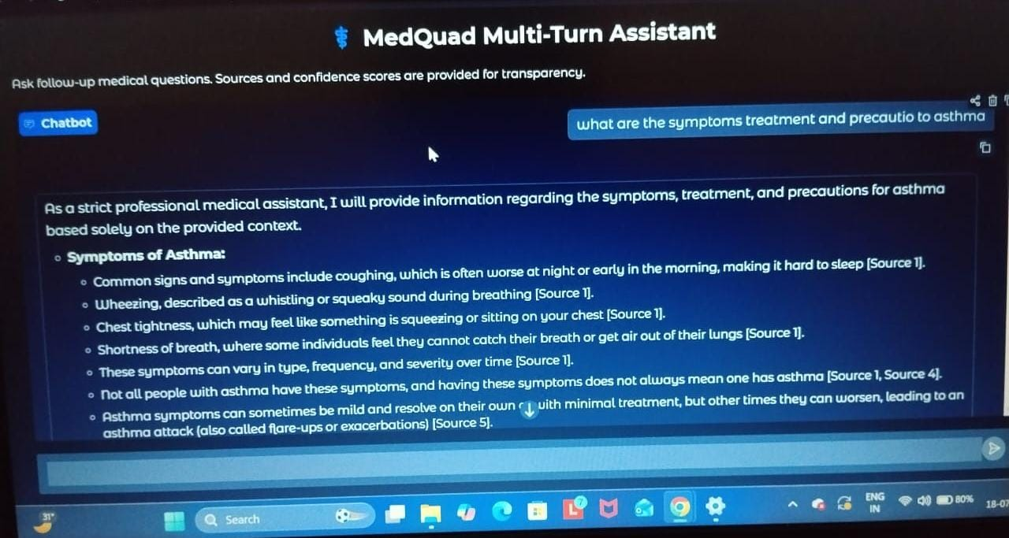
MEDQUAD ASSISTANCE WITH USER INTERACTIVE CHATBOT

